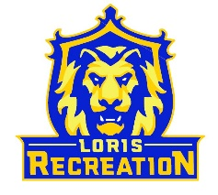
8U Gold Baseball
Schedule
Coach: John Mishoe
Date Opponent Location_______________
Saturday 4/2 @ 1:15 vs 8U Gray Field 1
Saturday 4/2 @ 2:30 at 8U Blue Field 1
Tuesday 4/19 @ 7:30 at 8U Gray Field 1
Thursday 4/21 @ 7:30 at Green Sea #2 Green Sea Recreation
Friday 4/29 @ 6:15 at Green Sea #1 Green Sea Recreation
Tuesday 5/3 @ 7:30 vs 8U Blue Field 1
Thursday 5/5 @ 6:15 vs Green Sea #3 Field 3
Tuesday 5/10 @ 7:30 vs 8U Gray Field 1
Thursday 5/12 @ 6:00 at North Strand North Strand Recreation
Tuesday 5/17 @ 7:30 vs 8U Blue Field 1
Thursday 5/19 @ 6:00 vs North Strand Field 1
Friday 5/20 @ 6:00 at Mullins #3 Mullins Rec
Monday 5/23 @ 7:15 at 8U Gray Field 1
Thursday 5/26 @ 6:15 vs Waccamaw Field 1

*Green Sea 5050 Tulip Grove Nichols, SC
*Mullins 1100 Gapway St. Mullins, SC
*North Strand 120 Hwy 57 South Little River, SC

