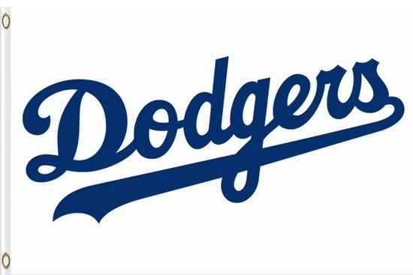

Schedule

Saturday 4/2 9:00 vs Pirates (Picture Day)
Tuesday 4/5 6:00 vs Orioles
Tuesday 4/19 6:00 at Athletics
Thursday 4/21 7:15 vs Cardinals
Thursday 4/28 7:15 at Braves
Monday 5/2 6:00 at Pirates
Thursday 5/12 7:15 at Orioles
Tuesday 5/17 7:15 vs Athletics
Thursday 5/19 7:15 at Cardinals
Tuesday 5/24 6:00 vs Braves

*All games will take place on Field 2 at Loris Sports Complex

