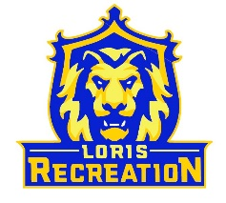
12U Basketball Team Clark
Schedule
Coach: Archie Clark

Date Opponent Location_______________
Thursday 1/26 @ 8:15pm (B) vs 12U Marksberry Loris High School
Monday 1/30 @ 6:15pm (B) vs 12U Bennett Loris High School
Saturday 2/4 @ 11:00am (B) vs 12U Purcha Loris High School
Thursday 2/9 @ 8:15pm (G) at 12U Bennett Loris High School
Saturday 2/11 @ 11:00am (G) at 12U Marksberry Loris High School
Monday 2/13 @ 6:30pm (B) vs Aynor #1 Loris High School
Thursday 2/16 @ 8:15pm (G) at 12U Purcha Loris High School
Saturday 2/18 @ TBD Post-Season Tournament Loris High School

(B) = wear Blue Jerseys
(G) = wear Gold Jerseys

*Dates/Locations Subject to Change

